Board Quality Management Council Committee Meeting Minutes

June 24, 2025, Bryant Center/TEAMS

9:00 am – 12:00 pm

Presiding: Jennifer White
Members: Chris Brabant, Amy Hermes, Rhonda Tesmer, Chris Schmitz, Pauline Cass, Michelle Abey, Glen Kruser, Tim Rusch, Donna Olson, Laura Mays, Sue Vanderbilt, Dr. Puneet Dhillon, Dr. Mark Menet, Jen White, Andy Boryczka
Present:
Absent:
Guests:

Agenda Item (Facilitator) | Discussion |  | Follow Up Action
QM Council Consent Agenda Oversight  - MCE minutes – June  - Board Quality Management Council minutes – May  - Patient Safety Committee minutes – June  - Infection Prevention Committee minutes – June | Motion to approve:  Second:  Discussion:  All in Favor:  Any opposed:
Root Cause Analysis
Regulatory Updates: DNV/CMS
Heather Kleinbrook-  Inpt  GP | MedSurg Patient Discharge Process:  Inpatient Boarding New Employees:  Increase Swing Bed Admission:  GPU Onboarding New Employees:
Tina Strandlie  ED | Isolation Signage:  Mass Casualty Drill: Active Threat Drill  Patient Follow-up after Missing Work and Work Comp Restrictions:
Kelly Harrington  Urgent Care | ED Onboarding New Employees  Urgent Cares Supply Ordering
Kyle Sippel  Lab (Zach)  Sleep | CAP Self-Inspection Follow Up  Sleep Center Succession Planning:  Sleep Center Visitor Sleeping:
Jason Schoville  Plant Operations | Employee Orientation Competency Checklist:  SHOC – Monthly Compliance Asset Management:
Sara Sturmer  Medical Imaging | New Employee Onboarding:
Sarah Watkins  REG – Jennifer Bothum  HIM – Victoria Valdez  PFS- Jordan Sweeney | Ortho Surgery Scheduling  HIM New Employee Onboarding:  HIM Coding Policy and Procedures:  Self-Administered Drugs Analysis
Deb Dahlke  Anesthesia – Amy Hermes | Controlled Substance Documentation:
Amy  Administration | DVC Score – Satisfaction Domain
CI Presentation Debriefing | Projects closing:
Notes: | Motion to Adjourn:  Second:
Parking Lot (items for next meeting)
Reviewed and Approved by: Jennifer White |  | Respectfully Submitted by: Rhonda Tesmer
NEXT MEETING: July 22, 2025 9:00 – 12:00 PM Bryant Center and/or Teams

Stoughton Hospital Medical Care Evaluation Committee Agenda/Minutes

June 17, 2025 (0730 in Lobby Conference Room and via Zoom)
Presiding: Dr. Mark Menet
Members Present: Dr. Schwaab, Dr. Rivera, Rhonda Tesmer, Amy Hermes, Erin Meronk, Chris Brabant, Jen White, Deb Dahlke,
Absent: Erin Meronk, Dr. Lind, Dr. Rawal

Agenda Item (Facilitator) | Discussion | Follow Up Action
Meeting called to order. Welcome to Dr. Lind
Approval of May meeting minutes | MOTION TO APPROVE: Dr. Schwaab  SECOND: Deb Dahlke
Re-appointments (Dr. Menet) | MOTION TO APPROVE: Deb Dahlke  SECOND: Dr. Schwaab
  Name | Title/Privilege | Dates of Review
  Houston, Courtney | APNP/ITP | 7/24/24-5/31/25
  Monti, Jennifer | MD/Cardiology | 7/24/24-5/31/25
  Rathkamp, Skyler | MD/Emergency Med | 7/24/24-5/31/25
  Ho, Benjamin | MD/Emergency Med | 6/1/23-5/31/25
  Strong, Christin | APNP/Emergency Med | 7/24/24-5/31/25
  Davidson-Fiedler, Marlise | MD/Hospital Medicine | 6/1/23-5/31/25
  Lawless, Paige | DO/OB-Gyn | 7/24/24-5/31/25
  Torres, Mark | DO/OB-Gyn | 7/24/24-5/31/25
  Greco, Margaret | MD/Ped Cardiology | 6/1/23-5/31/25
  Bailey, Tyler | MD/Radiology | 7/24/24-5/31/25
  Ballard, Elisabeth | MD/Radiology | 7/24/24-5/31/25
  Shirley, James | MD/Radiology | 7/24/24-5/31/25
  Peirce, Ryan | MD/Radiology | 6/1/23-5/31/25
  Moore, Nathan | MD/Urology | 6/1/23-5/31/25
Consent agenda items: MOTION TO APPROVE BY: Dr. Schwaab SECOND: Deb Dahlke
Committee Reports: May Board Quality Management Minutes, QSRC, Pay for Performance Scorecard, DVC scorecard, Patient Safety Minutes, Infection Prevention Minutes | Dean Scorecard Readmissions fell out, ok on one-day stays, and the satisfaction with the discharge instructions. Amy reminded the committee that this is very lagging data and is a rolling four quarters. Chris had reviewed that data with Jen, specifically the readmissions and those were readmissions at 24 and 28 days respectively.  Dr. Menet asked about the uptick in Controlled Substance Discrepancies in Anesthesia. Amy and Deb had reviewed these and these were all wasted but sometimes the amounts were different and corrected and there was no trending regarding staff. An example is giving med in PACU for pain, running back to the OR room to turn it over and then forgetting to go in and add the med to the anesthesia record. We did have two students during this time and that distraction may have been an issue. Amy is asking Michelle to investigate the add on where the Pyxis talks to the EPIC anesthesia record and provides a hard stop to get these wastes/amounts corrected immediately. Looking into whether EPIC/SSM will allow for the build for this technology.  Infection Prevention Notes: Reduced risk of infection related to devices: Dr. Menet asked if this documentation for continued use is a provider need or a nursing need and additionally asked if the use of the checklist for central line insertion was communicated to providers. Jen and Amy discussed the changes that were made to EPIC that made this more of a struggle to locate the documentation by nursing. Catheter days on the floor has been built into the progress note template for nursing. Dr, Menet stated that if hospitalists can assist please reach out. | Tomorrow at Administrative Council there will be an intensive discussion about IT. Chris encouraged all those with concerns or requests to get those to him prior to 6/18.
Medical Imaging Reports: MRI QA Summary
Lab: Associated Pathologists OPPE Metrics Report
Utilization Reports: Surgical Services Procedures & AIC Visits/Treatments,  GeriPsych Percent Occupancy; Average Hours per Inpatient Stay | For surgical services: GYN and General surgery are looking like they are on course to exceed budgeted procedures. Other specialties are close to budget or lagging a bit. AIC is trending to exceed budgeted visits. G/P Percent Occupancy is at 75% for May and 73% for the calendar year which is the highest percent occupancy since 75% in 2019. Inpatient discharges for Med/Surg/ICU/IMC subtotal are at the same level as YTD FY24 but the total is a bit lower. Discharge days are higher though. We remain below the 96-hour average at 68/per IP. Swing bed admissions YTD are at 19, trending up compared to 7 YTD 2024 and a total of 15 Sept of 2024. The average length of stay, YTD is 2.23 | No action required
Organ/Tissue Procurement Review-May  END of CONSENT AGENDA ITEMS | No eligible donors for May. No anatomical gifts made.
Old/Recurring Business-
Stroke Alert Policy | Changes were emailed out and consensus obtained. Policy forwarded to MEC for approval. Matter closed.
New concerns with Radiology | Dr. Menet is meeting with Dr. McGuire and will discuss the expectations and also who to meet with in their corporate structure regarding these issues and to discuss possible solutions.  Dr. Schwaab asked about a recent delay in getting a read (3+ hours for an abdominal imaging for ER and Dr. Schwaab was asked to read it). It seems that there may have been a system failure issue that particular day. There was another issue where a Stroke CT was done and the hotline was called but the person manning the hotline didn’t read stroke CTs and it still took 30 min to get a read. Dr. Menet requested a list to discuss with Dr. McGuire and his schedule. Chris recommends doing the search in two windows: the last 8 months and then a look back at a similar time span before we had troubles. Amy said that other CNOs are struggling with the same issues with same and other radiology groups. | Dr. Menet has not heard back from Dr. McGuire. Amy will have Sara Sturmer send Dr. McGuire’s schedule to Dr. Menet and he will stop in to talk with him when he is in Stoughton. Dr. Menet asked for a list of imaging things. Amy will do a search in SZP in two windows of time and she will speak with Sara.
Recent Root Cause Analysis (Jen) | D/C meds issue with an external pharmacy that lost internet service.  We learned a lot and it was an isolated incident where power was lost at the receiving end.
Delinquent records | None as of June 10, 2025
30-day readmissions report by month | The rate of 4.1 readmissions/100 eligible discharges is based on our actual data of 2 readmissions for 49 eligible discharges for April. Both patients were originally admitted with infections (one with UTI/probable norovirus and one with sepsis and pneumonia). Both index stays were short (1 day and 2 days respectively). Both patients returned within a short period of time (2 days and 4 days respectively). Both were discharged to home on the index stay (1 to her personal home, 1 to assisted living). One returned with altered mental status/acute psychosis. The other patient returned with respiratory failure after developing COVID at the assisted living facility where there was an outbreak. Both readmission stays were 3 days in length. Following the readmission, both were discharged to a different level of care (1 to Meriter and 1 to Swing Bed Status). Both were Medicare patients.
Inpatient Code Reviews
Accreditation/Regulatory Updates | Discussion about the challenges with Stroke Ready Certification, related to the number of patients who receive thrombolytics (need 5 within a 2 year span and we struggle to see that many patients who are eligible. We are still continue working on meeting the criteria where we can with the GWTG measures.
IT/EPIC challenges-Amy
OPPE/FPPE (concerns only) | No concerns.
New Business/Current Clinical Process Issues
Next Meeting | Do we need to meet in July? Meeting would be July 15, otherwise August 19 | Keep on calendar as a place holder.
PEER REVIEW | Administrative team dismissed.
Mortality Review- | One death in May, no criteria for review.
Surgical Complications/Cancellations for Apr/May | One case for preliminary review. No concerns identified. | Dr. Menet will sign and get this to Rhonda.
Medical or ED Care Case Review
OTHER BUSINESS | Ceribell is a bedside EEG device that can determine seizure activity. Subscription agreement is being vetted by our legal team.  Mobile MRI may be cost prohibitive Is this something that we might find useful. There is a cost/month and per Dr. Menet, it may be more beneficial to increase staffing to utilize the machine that we have.  Chain of Command policy was looked was reviewed by providers and Amy expressed thanks to the providers for that assistance.
Parking lot
Adjournment: | With no further business to attend to meeting adjourned. | Next meeting: July 15 or August 19
Signature |  | Date:

OPPE June Review (Highlighted individuals are still in FPPE process as new providers.)

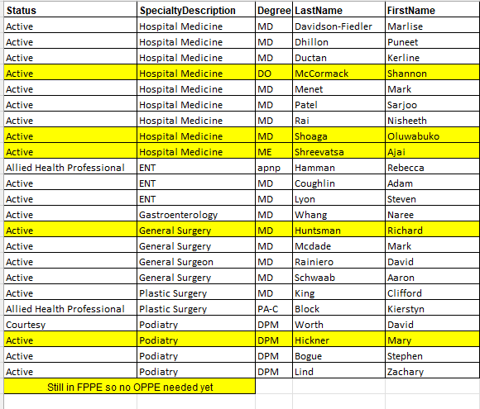

Board Quality Management Council Meeting Minutes

May 27, 2025 Bryant Center/Microsoft Teams

9:00 am – 12:00 pm

Presiding: Jennifer White
Members: Chris Brabant, Amy Hermes, Rhonda Tesmer, Chris Schmitz, Pauline Cass, Michelle Abey, Glenn Kruser, Tim Rusch, Donna Olson, Sue Vanderbilt, Laura Mays, Dr. Puneet Dhillon, Dr. Mark Menet, Andy Boryczka, Jen White
Present: Chris Brabant, Amy Hermes, Rhonda Tesmer, Chris Schmitz, Pauline Cass, Michelle Abey, Glenn Kruser, Donna Olson, Sue Vanderbilt, Laura Mays, Jen White
Excused: Tim Rusch, Dr. Puneet Dhillon, Dr. Mark Menet, Andy Boryczka,
Guests: Jonathan Milton, Cathy Grabowski, Jen Mora, Skyler Debilzen, Paige Swatek, Ari Zimbric, Sandra Bryan Armstrong, Angie Rowin-Tippit, Emily Syring, Autumn Kumlien, Kristin Brickl, Nancee Linnerud, Dacia Brunner, Brian Swain, Kate Stanard, Taylor Simonson

Agenda Item (Facilitator) | Discussion | Follow Up Action
QM Council Consent Agenda Oversight  - MCE minutes – May  - Board Quality Management Council minutes – April | MOTION to APPROVE by: Sue Vanderbilt  SECOND: Glenn Kruser  Discussion:  All in Favor: All  Any Opposed: None
Root Cause Analysis | No new RCAs since last meeting. New one is being undertaken on ePrescribe that failed with a discharge patient, and we are not sure where the failure occurred (our side or the receiving pharmacy side)
Regulatory Updates: DNV, JC and CMS | No new updates. Email sent to DNV related to the SHOC location. Will determine whether to add that location, and we will be adding the Cottage Grove Urgent Care Location to our application.
Cardiology Dept-- Jonathan Milton | Cardiac HEAL Program  KOM: 1) Creation and initiate Secondary Prevention Program by November 2024. 2) Identify and Implement documentation template [billing/coding] by October 2024. 3) Evaluate quality of life metrics for heart failure in pilot group via health-related quality of life tool (COOP) by April 2025.  Current KOM: 1) complete 2) complete 3) complete  The pilot program has been completed. 100% of pilot patients under 70 years of age demonstrated an improved or sustained COOP score in all categories. Of those in the subset of the pilot, patients varied in number of sessions between 4 and 11. Pilot program has been completed, and project lead is requesting approval for project completion. The program is incorporated into our clinic workflows. Plans are to transition and offer Group Medical Visits which may be grant funded. | APPROVED FOR PROJECT COMPLETION.
Liz Touchett  Cardiac Rehab- Cathy Grabowski  Employee Health -Jen Mora  Rehab Services- Skyler Debilzen | Cardiac Rehab Electronic Phase 3 Exercise Referral  KOM: 80% of Phase 3 exercise referrals to be placed electronically versus a paper referral  Current KOM: 100% completed. The CRR15 order was created and went live on 02/13/2025. Testing was done for approximately one week and the ticket was closed on 02/19/2025. The team began using electronic referrals on 03/01/2025 through 05/07/2025. We have had 4 patients who have SSM providers where the CRR15 referral was placed. 100% of these referrals were placed successfully. Project Lead is requesting approval for project completion.  Health Promotion and Injury Prevention in the Workplace:  KOM: Full implementation of return-to-work process, new and current employee functional screening by 12/2025. (6 steps to reach completion). 1) Develop functional screens for assessing physical ability to meet physical demands of the job. 2)Implement functional screens for new employees. 3) Update job descriptions with new job strength charts. 4) Determine plan for completing physical screens on current employees. 5) Consult legal for employees that do not pass functional screens for new employees, current employees, and employees returning to work after surgery/injury/illness. 6) Complete functional screens on current employees  Current KOM: 50% completed. 1) Completed 2) Completed 3) In progress. 4) Not started. 5) Not started. 6) Not started.  Job description updates started in April. Met with Forum in April to review job categories and discuss implementation of functional screens for current employees. The managers know their employees’ job duties best, so they can verify the correct job strength category. Managers have reviewed all jobs and confirmed job strengths are correct.  Inpatient Workflow:  KOM: 1) All inpatient and medical evaluations to be completed within 48 hours (~2 days) of admission. 2) Geri-Psych evaluations to be completed within 72 hours (~3 days). Note: Inpatient PT hours reflect 10%, 0.9/0.95 FTE on a weekly basis, and inpatient OT hours reflect 10% 0.75-0.82 FTE on a weekly basis.  Current KOM: We are tracking for the next month.  We currently do not have any written standards for inpatient evaluations. As surgical services grow, our therapy services need to grow to ensure we are providing quality care for our clients. Our team has come up with an OT and PT schedule to monitor weekly FTE for inpatients. New key outcome measure set up to help assess progress toward goal. Updates have been made to the PT and OT inpatient binders to help train staff with dot phrases created for documentation. Lists were created for what can be done when there is a high and low census. Challenge is the ongoing variability, but we are working to address this. PT is addressing transfers and ambulation etc. OT is addressing activities of daily living. | APPROVED FOR PROJECT COMPLETION.  Project to continue.  Begin updating job descriptions May 2025, with a completion date of June 30th.  Determine cadence and implement functional screens of employees by fall 2025.  Project to continue.  Continue to track over the next few months FTEs and evaluations to help assess progress towards our KOM. We note FTE is slightly over currently due to onboarding/training, so we expect to see it normalize once that is complete.
Pauline Cass  Pharmacy- Pauline  Presented by Paige Swatek & Ari Zimbric | New Employee Onboarding:  KOM Target: 100% completion of new employee orientation program implementation by June 2025.  Current KOM Status: 5/6 steps completed (83% completion).  The team developed a weekly touch base checklist to ensure standardized documentation for training. Staff want more feedback during the onboarding process, which prompted the addition of a daily preceptor touch base and more formal weekly feedback sessions. Information retention has been increased using a tell/show/do/review method. The binder review will occur with the annual policy review or as needed for new employees. We do have an upcoming Pharmacist vacancy (due to a relocation) which presents us with an opportunity to use the completed binder.  Medication Ordering Workflow:  KOM Target: Develop medication ordering cards, including PAR levels, for 100% of pharmacy-stocked medications, excluding IV medications (these are in the Duo Station with pre-determined PAR levels), with a completion date of December 2025.  Current KOM Status: 82/797 Medications (10% completion).  With our medication wholesaler switch to Cardinal, the SSM contract stated we could no longer receive mediation orders on Saturdays. Our current medication ordering is a replenishment system, and we order as medications are used. This is a manual process and sometimes means medication orders are missed when stock is low. This has become a larger issue now that we need to anticipate medication usage for the weekend. Establishing a minimum stock to have on hand (PAR level) will assist with ensuring we have enough medications for the weekend. The team created bins for medication cards to have a centralized area for ordering information. Fast moving medications in the pharmacy have been determined. These are medications that are ordered most often, creating more opportunities for error. There is opportunity for this to make removal from formulary an easier and more efficient process, as well as making additions more streamlined. | Project to continue.  Develop preceptor training guide by June 30, 2025. Pauline is getting the posting for the Pharmacy position ready. She notes that next year there will be a retirement as well, but no date is available yet.  Project to continue  Still working on completing the master list of medications. The team will research and order the med bins by June 30, 2025.
Surgical Services-Sandra Bryan Armstrong | Ambulatory Infusion Center (AIC) Improved Workflow:  KOM Target: 1) Full implementation of improved AIC workflow to decrease infusion denials. Step 1: Analyze. Step 2: Develop Step 3: Implement.  Current KOM Status: Step 1: Analyze – In progress.  We know that better communication is needed with Surgical Services HUC and RNs of the importance of prior authorization process and the cadence of scheduling. AIC hours are from 9:00 am – 5:00 pm. Staff were scheduling to fit their schedule not the needs of the patient. We now have an RN scheduled to be there for those hours. Pharmacy plays a role in infusions; we met with them recently to introduce the project and begin looking at the workflow between Pharmacy and Day Surgery team when transition over care plan entry. We will have the RNs schedule and put in the treatment plans, rather than the HUCs. This should help patients anticipate the time it will take. Prior authorization is a medication specific need. We do have a color-coded list that helps us to identify which drugs don’t require the prior auth, to the ones that need to be watched, to the ones that must be authorized for each administration.  Stabilization of Staffing:  KOM: 50% reduction of agency use by July 1, 2024. 100% reduction of agency use by October 1, 2025.  Current KOM: Agency Usage at the start of the project was 6.3. As of June 2025, we will be at 1.9 FTE which reflects a 70% reduction.  The surgical tech that started in December as part of our ‘grow your own’ program, completed all 125 required cases and is fully certified.  Recruitment of STs continues to be challenging. We have had 2 applications since 09/28/2024. Unclear as to why there are so few STs. We are looking to try to hire more sterile processing techs and OR assistants. We started the project with a KOM metric based on FTE but that doesn’t capture the financial savings related to the renegotiations when contracts are renewed. However, in the interest of consistency, we will continue to report in our original KOM Metric. | Project to continue.  Pharmacy to transition ownership of entering treatment plan into EPIC to Day Surgery Nurses by Aug 2025. By August, we should be able to determine if the scheduling will be transitioned to registration or remain with AIC.  Project to continue.  Continue to ‘grow our own Surgical Tech’ with OR assists and sterile processing techs. Continue to work with Black Hawk Tech taking SPD and Surgical Techs students. Although we have continued to use travelers, we have been negotiating to reduce rates of pay. Will continue to work to reduce costs of travelers. Would like to see specific goals/timelines/assigned individuals in the “next steps” section going forward.
Environmental Services- Angie Rowin  Emily Syring | Hazardous Waste Accumulation Area Inspection  KOM: Full implementation of a Hazardous Waste Accumulation Area Inspection program (4 steps to reach full completion)  Current KOM: Step 1: Create Hazardous Waste Accumulation Log - Completed. Step 2: Implement inspections two times a week - Completed. Step 3: Education - In progress. Step 4: Share audit results at EOC - In progress.  Weekly inspections continue. Hazardous Waste Awareness training is in progress and expected to be completed in June. Standing agenda item for Environment of Care Committee meetings to be reviewed has occurred. Findings were shared at the April meeting.  Environmental Services Onboarding New Employees:  KOM: Implement updated/improved new employee onboarding by June 1, 2025 (4 phases to reach full implementation1) Revise current employee checklist. 2) review revised/updated checklist at next staff meeting. 3) Schedule an initial meeting with EVS Coordinator/staff. 4) Implement with new staff during the onboarding process.  Current KOM: 1) Completed. 2) Completed 3) In progress. 4) Not started.  Team meetings continue to discuss continued planning of education and implementation. This has helped with team building, staff acceptance, input, and to garner staff support. | Project to continue.  Hazardous Waste Awareness training for selected EVS staff to be completed by June 30, 2025.  Report audit findings during EOC meetings in June and August. Angie has a goal of turning the pickup of hazardous waste produced by Dean-SSM back over to their system. Historically, we were doing that for them, along with their managing their manifests and black box waste. This is the last item to transition over and Angie will meet with Michelle to discuss that. Chris added that we still own the building and that does make us responsible for what is happening here so proceed with caution. Be sure that the responsible party is identified with next steps on slides.  Project to continue.  Bring department checklist final draft to seek input from staff at the next EVS team meeting in June.  Review/revise all job descriptions by July 1st.  The team will implement the new onboarding process with a new employee. (Goal is in August if possible.)
Food and Nutrition Services -Autumn | Hot Meals for Patients for Dinner:  KOM: Press Ganey satisfaction score for FNS > 90 percentile  Current KOM: MedSurg = 76th percentile for this past quarter, Geri-Psych 99th percentile for this past quarter.  The team implemented a standalone survey that Guest Services rounds a few days a week. The survey allows us to get real time feedback and to see how the Press Ganey comments compare to this feedback. The team is focusing on the feedback from the concierge during patient rounding. We are trying to address things in real time with options (new liquid salt substitute, etc.) and education.  Patient Meal Ordering Software:  KOM Target: New software program will be researched, picked, approved and 100% implemented by May of Fiscal Year 2026 (5 steps for full implementation).  Current COM Status: Research is in progress.  A Kickoff meeting was held to introduce the project, determine key stakeholders and begin researching platform options. We sought recommendations from other rural hospitals to help determine our top two software options. We are leaning toward HealthTouch since that is the vendor that SSM Janesville is using, and they were previously using Horizon. Many of the RWHC hospitals are using that system and some who aren’t, report that they are needing to use some manual work arounds with the system that they are using but chose that one due to cost. We must have a system that works with EPIC AND that SSM allows an interface with and will support into the future.  We are currently having trouble with our printers that should be recognizing the IP address and print our meal tickets is not always doing this and it has resulted in manual processes. | Project to continue.  The team will be working on the comparison data between the two surveys and provide the results at the next QM meeting for Cohort B in July.  Continue to train staff on how to cook new items on the menu. Test new menu items to help classify IDDS, print updated menus, track and trend over 6 months to see if actions implemented have made a difference.  Project to continue.  Gather input from RWHC hospitals for preferred systems and schedule demos for the top two software platforms by end of May 2025.  Michelle and Marcia are trying to ascertain from SSM that the interfaces will be available and supported for the software that we will select.
Ortho Clinic- Kristin Brickl | Total Hip/Total Knee Arthroplasty Patient Reported Outcome-Based Performance Measures:  KOM: >90% THA & TKA PRO-PM program pt completion rate among eligible hip and knee surgery patients within three months (08/01/2025) of implementation (05/01/2025) with the Oberd Registry (the vendor).  Current KOM: No data available at this time. Soft launch of the Oberd tool workflows & education of staff and patients has begun.  The team drafted and piloted workflow with IPad tools with patients and staff to ensure ease of use, workable, and sustainable. Consideration of both staff and patient burden to administer the tool. We will be meeting with Oberd monthly for optimization review and reporting templates. The team has been working on updates to communication protocols within Oberd’s tools for both email and text communication. We are also working with the vendor on options within Tableau. The working meetings with the vendor support have been very helpful. | Project to continue.  Monthly review of data for process improvement and sharing with key stakeholders at ortho meeting continue to occur on a monthly basis. IPad Office completion option to be determined by June 5th. Draft and distribute workflow, patient educational materials for patients explaining the purpose and benefits of PROMS by June 5th.
Dacia Brunner  Material Services- Nancee Linnerud  Accounting- Dacia  Brian Swain | Improvement for Ordering Department Supplies:  KOM Target: Review and improve the ordering processes in all identified department areas by completing 4 main steps (template updated, correct items stocked, storeroom labeled, electronic ordering).  Current COM Status: 32%. Completed 6 of 19 currently identified ordering areas/department.  With Ortho Stoughton, General Surgery and Urology moving to the new SHOC location, we wanted to ensure they were set up in their new storeroom right from the start; therefore, MV overing templates were updated, and labels were printed for the storeroom. General Surgery and Urology all 4 improvement steps have been completed. RT department has been set up with an MV ordering license and login so they can place orders through Multiview electronically. Before this change, staff were coming down to the storeroom to shop and pull items from the shelves themselves. This is a time saver for all the departments completed. The other advantage pointed out is the standardization of processes. We also discovered some non-stock items that were frequent back-order situations and some we can keep a box on hand to eliminate the back-order anxiety and that decreases the urgency and the tendency to hoard an item like that. Dacia reports that the response has been very positive by the departments who have experienced it.  Cash Spreadsheet Overhaul:  KOM: Improve cash reconciliation file functionality with formulas and increase reporting received to reduce daily reconciliation questions by June 30, 2025.  Current KOM: 60% completed.  The current spreadsheet is a work in progress. We have made changes, and the new file is in the testing phase. We are working out the kinks as we dual enter the file with the PFS team. The next step will be testing the accounting side on the PFS spreadsheets and working through any issues. Hoping to fully transition to the new spreadsheet by the end of May.  Upgrade Multiview and Convert QuickBooks:  KOM: Upgrade Multiview to V23 by April 30, 2025. After the upgrade to V23, reassess the need to convert to QuickBooks to Multiview for 3 related entities.  Current KOM: ~100% completed.  We successfully upgraded to V23 on 04/15/2025. We have reassessed the need to convert Quick Books to Multiview and decide not to make the conversion for the Foundation, MRI JV, and Gift Shop. Danielle discovered that we could have cost savings for QuickBooks through Tech Soup, which offers savings for Non-Profit organizations, and we qualified. There were several lessons that we learned. There are some changes I the way security is set up in V23 which requires a change to our internal process. The changes are good, as they enhance security, but will require a different workflow for us. V23 takes some time to get used to. The change from a forms-based interface to a web-based interface is a different look and feel. Setting up new entities in Multiview is a complicated process. It would either require a consulting project with Multiview or a lot of extra time for the Accounting Team to try and set up our selves. We will continue to help users as they use V23 and trouble shoot any processes that need further addressing in V23. Project Lead is requesting approval for project completion. | Project to continue.  Finish labeling Anesthesia, OR storerooms, PT/OT/Cardiac Rehab at SHOC followed by Oregon PT by July 2025.  Finish validating Ortho Stoughton stocked items and implement Ortho Mad by July 2025.  Project to continue.  Will continue dual entry with PFS for the next couple of weeks. After close is complete, start testing of the PFS Spreadsheets by accounting. Will troubleshoot existing issues and test the functionality (this will last a while). Targeting full implementation of new spreadsheet by June 2025.  APPROVED FOR PROJECT COMPLETION.  Chris asked to provide a list of other software that is used in our organization that Brian can investigate if it may be available for us through Tech Soup.
Public Relations: Laura Mays  Kate Stanard  Taylor Simonson | New Employee Onboarding:  KOM Target: Implement updated/improved new employee onboarding by 09/30/2025 (4 steps to reach full implementation)  Current COM Status: 1) Initiation – Completed 2) Planning – in progress. 3) Execution – not started 4) Closure – not started.  We’ve reviewed and gathered additional marketing specific policies to add to the checklist to ensure new team members are aligned with departmental standards, brand guidelines, and compliance requirements from the start, promoting consistency and reducing onboarding errors. We had the PR team review job description which will be added to the onboarding checklist/binder. Met with police officer to determine plan in case of an emergency to ensure all CHWC is informed on what to do if there is an emergency, and to document the plan in the binder to review with all new employees. We’ve learned that the marking department needs a tailored onboarding process due to our off-site location and unique needs that differ from other departments. After meeting with the police officer, we learned how important it is to have a clear emergency plan in place, including where to meet and what our best options are in different situations. Since we are a small department and don’t experience many changes, it’s especially important to make sure this information is shared with new coworkers during onboarding. Christopher encouraged Kate to keep the Emotional connections with new employees in mind and Michelle recognized that it is equally important to spend some time and attention on a preceptor guide in case someone else needs to fill in the gap for someone’s orientation.  Employee Giving:  KOM: Have 40% of employees give to the Stoughton Hospital Foundation. 153 employees out of 386 employees (number of employees on 10/01/2024)  Current KOM: 51%, 195/386 employees (as of 05/06/2025).  The team continues to look for new opportunities. We found that by adding in new competitive ways for employees to donate, it is helping to increase the number of employees donating. | Project to continue.  Kate: Develop a plan for new employees first week in department, mentor, welcome potluck, tour of building, go over panic button by 06/02/2025.  Kate-Create an online folder with all new onboarding items for PR and a binder to have out at CHWC by 06/10/2025.  Kate- Meet with PR team to determine the next steps, and how often we would like to review this by 06/17/2025.  Christopher hopes to be able to share all of the best practices related to onboarding once all of these projects are completed.  Kate will connect with Taylor Simonson, since she works with new volunteers and there maybe some of this that is useful to her.  APPROVED FOR PROJECT COMPLETION.  Foundation Board will review new ideas during Strategic planning process.
Chris Schmitz  Human Resources | UKG Hosted Centralized Coaching and Discipline:  KOM: 100% employee coaching or discipline using UKG platform.  Current KOM: OnBase solution 100% completed.  The new tool is available for use. All new coaching and discipline of any kind is communicated using this tool. Project lead is requesting approval to close this project.  New Hire Scheduling in EPIC  KOM: 100  % of new hires are scheduled by HR versus going through the Registration department.  Current KOM: New project, just getting started.  We strive to provide the best new hire onboarding experience possible. At times, when scheduling a new hire, it can feel like a long phone call requiring many phone transfers. This new process would provide a more seamless new hire experience at one of the first interactions with Stoughton Health. HR is open to doing this task if it means better new hire experiences and increases new hire retention. | APPROVED FOR PROJECT COMPLETION.  Measure leader sentiments on using the new process by May 27, 2025  Project to continue.  Jenifer, Melissa and Tonya-- Schedule Epic training by June 15, initiate new hire HR scheduling into EPIC and then track time spent with HR now scheduling for a 4-week period- Implementation up to 8/1/25.
QM Presentation Debriefing | Projects closing:  - Cardiac HEAL Program  - Cardia Rehab Electronic Phase 3 Exercise Referral  - Upgrade Multiview & Convert to Quickbooks  - Employee Giving  - UKG Hosted Centralized Coaching and Discipline
Other business | Question if we need to have 7-8 minutes scheduled in between to allow for questions and to be better able to stay on schedule.
NOTES: | Motion to Adjourn: Donna Olson  Second: Chris Schmidt
Parking Lot (items for next meeting)
Reviewed and Approved by: | Respectfully Submitted by: Jen White
NEXT MEETING: June 24, 2025 9:00 - 12:00 PM Bryant Center or Microsoft Teams

Stoughton Hospital Patient Safety Committee Meeting Agenda

May 28, 2025 1:00 – 2:00 pm Bryan Center/Microsoft Teams

Members: Rhonda Tesmer, Heather Kleinbrook, Bill Wilson, Angie Rowin Tippit, Jen White, Kyle Sippel, Amy Hermes, Tina Strandlie, Sara Sturmer, Nikki Rowin, Jen Mora, Pauline Cass, Kelly Harrington, Josh Bartz, Amy Dunn

Present: Rhonda Tesmer, Heather Kleinbrook, Bill Wilson. Angie Rowin Tippit, Jen White, Kyle Sippel, Amy Hermes, Tina Strandlie, Pauline Cass, Kelly Harrington
Absent: Sandra Bryan Armstrong, Jen Mora, Josh Bartz, Amy Dunn, Sara Surmer, Nikki Rowin

Agenda Item (Facilitator) | Discussion | Follow Up Action
Approval of Previous Minutes | Review and approve March. | Approved by the team.
Standing Business
Medication Management Data Review - Pauline | INCLUDEPICTURE "cid:image002.png@01DBC34E.3304A750" \* MERGEFORMATINET 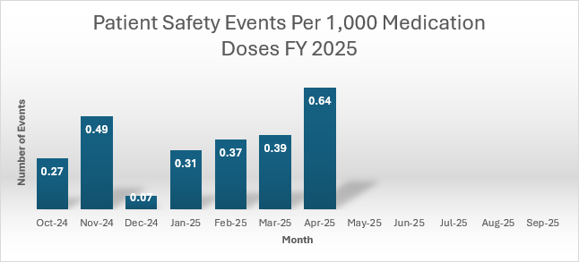  NOTE: The graph is for internal use only for tracking and trending purposes. | The increase is noted in April and it includes the controlled substance discrepancies.
Controlled Substance Discrepancies | KOM:  Administration documentation discrepancies 0%  Waste documentation discrepancies < 2%  Discrepancy resolutions within 48 hours of discovery should be 100%  Recommended KOM:  Administration documentation discrepancies 0  Waste documentation discrepancies < 1  Discrepancy resolutions within 48 hours of discovery should be 100%  The discrepancies for March were as follows:  Geri Psych: 1 administration documentation discrepancy  Anesthesia: 6 waste documentation discrepancies; 1 administration documentation discrepancy  Med Surg: 1 administration documentation discrepancy  We did not meet either goal this month.  INCLUDEPICTURE "cid:image002.png@01DBC349.95808B60" \* MERGEFORMATINET 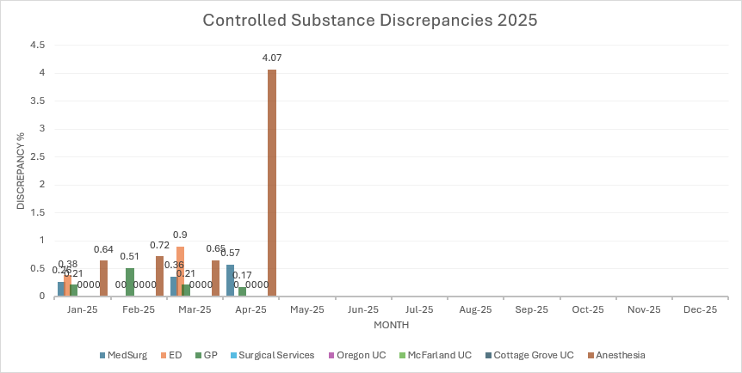 | We did discuss the fact that a discrepancy means things did not match. Even if everything is accounted for when we do the follow up, it doesn’t get removed because what we were expecting didn’t match what we found, and that still occurred. It is not an indication that we didn’t find it or figure out what the issue was. Resolution is defined as get it resolved within 24 hours and that is really challenging. Pauline is recommending changing the resolution to initial follow up within 24 and resolution in 72 hours.  Recommend discrepancy of 0-1, not a percentage.  The CRNA items are in Amy’s office.
   | Jan | Feb | Mar | April
  Med Surg | 0.26 | 0 | 0.36 | 0.57
  ED | 0.38 | 0 | 0.9 | 0
  Surgical Services (AIC/OR-Core) | 0 | 0 | 0 | 0
  Oregon UC | 0 | 0 | 0 | 0
  McFarland UC | 0 | 0 | 0 | 0
  Cottage Grove UC | 0 | 0 | 0 | 0
  Geri Psych | 0.21 | 0.51 | 0.21 | 0.17
  Anesthesia | 0.64 | 0.72 | 0.65 | 4.07
Barcode Scanning – Pauline | Our goal is 95% compliance. Our average compliance rate in January was 92% and we have dropped to 84% in April.  INCLUDEPICTURE "cid:image005.png@01DBC34E.3304A750" \* MERGEFORMATINET 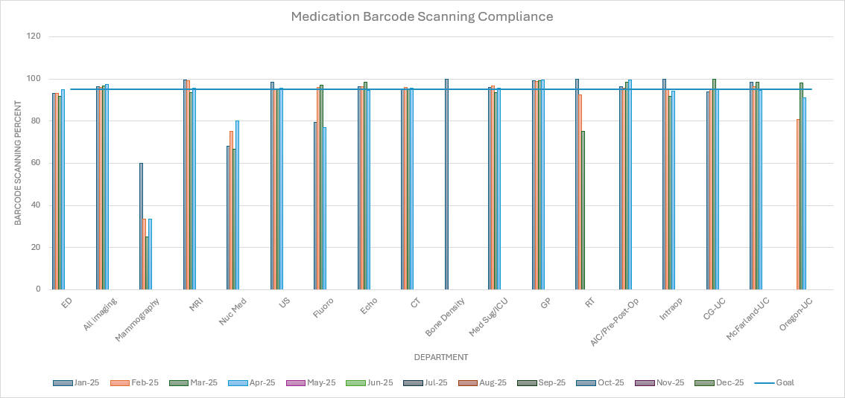
Disposal of new antibiotic bag adapters. | The new adapters have a very large needle. We don’t want nurses pulling those apart due to the risk of injury. The package insert doesn’t advise where to dispose of it but does advise not to take them apart once assembled. These are not in the patient care areas currently. Pharmacy held them back and they are using alternatives until nursing staff can be educated on the proper disposal. | Angie researched this and it should be going into the red bins. She will bring red bins of two sized for the units to determine what will work best. Tina emailed follow up to Sam Stolz to add this instruction to the IV Pump education in JUNE.  Pauline will show Sam the device.
Review of Safety Zone Event Data-Quarter 1 CY 2025 (Jan – Mar) | Summary was reviewed. See the summary for details.  Discussion about the critical lab communication (6) for the quarter but 4 of those were the same ER patient, who was critical, and they were in the process of trying to transfer the patient. .Outside of that there were only 2.  Tina discussed three incidents where patients at SHOC were “not feeling well” or had a fall and were brought by staff through the tunnel to ER. Additionally, some have requested items for SHOC (crash cart, go-bag, Ambu bags). We need to be very clear what should happen. Call 911, BLS +AED until EMS arrives. | Recommendation: we need to be consistent in our policy, complete SZP if this happens.
Patient Safety and/or Construction
AHRQ Safety Survey | We are due for a survey. Plan is to send out the survey this fall. There is a Clinic survey and a Hospital survey in SZP. Team to determine if we will use both surveys or only the hospital survey. | Team to review Clinic and Hospital survey at next meeting.
Security Concerns – All

Risk Management Claims
2025 Patient Safety Goals | Goals:  1) Falls (Sentinel Alert and reporting requirement of our SZP grant)  Hospital Fall Goals: Balance score card in the past rolling 6 months met goal with no issues.  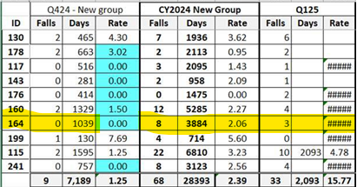  2) Global Immunizations for Inpatients (Influenza):  3) OFI from DNV- Jen will provide the spreadsheet with the OFI’s at Forum and will be setting up meetings to review chapters.  4) DNV Standard Chapter Review – look at the chapters prior to the meeting and pay attention to the surveyor guidance parts to anticipate what they might be asking for.  New items in the manual are blue. We have been reviewing the chapters and Jen is following up on action items from previous meetings. Hope to be done in June.  5) Controlled Substance Discrepancies – see above (NEED TO DETERMINE KOMs)  6) New Goal: All Non-violent Crisis Training: KOM: Enlist in RWHC to train as many employees as possible in the next year (max attendance of 30 employees/per session, 5 sessions/year) and biannual training for active threats.
Best Practice Research for Medication Administration in the Clinic Setting | Tabled.
Restraints and Seclusion Review -  Rhonda | None
Root Cause Analysis and/or CI Project Updates | Epic E-prescribe transmission failed resulting in the patient’s pharmacy of choice not receiving the scripts. Pauline said that it shows up as a time out error, which is on the receiving end, not the sending end. This appeared to be an isolated incident but its worthwhile to look into this. There was a concern about the nocturnist not seeing the message and Amy wonders about overload of communication.
Antibiotic Usage – Pauline/Bill | Still awaiting the dashboard.
Stroke – Amy Dunn | We are not probably going to be able to get the ASRH certification. We will still be participating in the Get with the Guidelines. Stroke Alert Policy went to MCE and some changes were made. | The policy will go to MEC. Rhonda will validate that all are in favor.
Excessive Radiation Exposure (ALARA) DNV MI Chapter - Sara
DNV Expanded Internal Audit – Blood Transfusion Process – Kyle | No new updates
Regulatory/DNV Readiness – All
Joint Commission – Sentinel Event  Alert | No new articles
Joint Commission – Quick Safety Monthly Articles | No new articles
Other Discussions: |  | Add NPSG to next meeting for team to discuss and review.  New Members: Add JoDeen and Pam to this committee for July meeting.
 | Next meeting: July 23, 2025 - 1:00 – 2:00 pm Bryant Center/Microsoft Teams
Submitted by: Jen White

Infection Prevention Committee Meeting Minutes
Wednesday, May 28, 2025 2:00-3:30 PM
Bryant Conference Room B or Microsoft Teams

Present: Heather Kleinbrook, Rhonda Tesmer, Amy Hermes, Jennifer White, Kyle Sippel, Tina Strandlie, Kelly Harrington, Jen Mora, Bill Wilson, Angie Rowin-Tippit, Kelly Harrington, JoDeen Hettenbach, Pam Engelhart.
Topic | Presenter | Background | Discussion/Additional Information | Follow-up
Welcome New Committee Member | Committee | Pam Engelhart, Multispecialty Clinic Manager (Cardiology, General Surgery, Urology, Wound)
Approval of March 2025 Meeting Minutes | Committee | Review and approve | Approved
Standing Agenda Items
Policy Review | Bill Wilson | Policies to review:  13.05 Isolation Precaution Guidelines  13.14 Maintaining Integrity of Sterile Supplies  13.30 Water Damage and Restoration  13.02 Medical-Infectious Waste from the Public  13.13 Collection and Transportation of Soiled Linen  13.17 Management of Blood. Body Fluid Spills  13.32 Legionella Water Management Plan | See Summary of Changes.  No additional changes were recommended by the committee for these.  Amy did discuss the reference to Joint Commission Sentinel Event Alert in Policy 13.14. But in our defense, DNV does not have these alerts which contribute to the formation of best practice. Nothing on the DNV website is equivalent to the National Patient Safety Goals, etc. So we are looking at these and the Sentinel Event Alerts because they are publicly available and represent best practice.  Jason had reviewed 13.17 and 13.32 had no recommendations for changes.
Risk Assessment/ Program Goals  and  Infection Prevention Dashboard | Bill Wilson | Q1CY2025 IP Program Goals/  Q1CY2025 Infection Prevention IP Dashboard:  See Charts below  Goal Not Met  - Reduce ICU and MedSurg Urinary Catheter Standardized Utilization Ratio to <1 in 2025.  - ICU = 1.28  - Med-Surg = 0.875  - CLABSI Standardized Utilization Ratio (SUR)-ICU = 2.169  - 100% of Central Lines will have documented "rationale" for each hospital day counted in 2025 = 89.3%  - 100% of all non emergent central lines inserted with utilize a Central Line Checklist in 2025 = 0%  - 98% of Urinary Catheters will have documented "rationale" for each hospital day counted in 2025 = 86%  - Healthcare Personnel Significant Exposures Goal 0 = 3, none for April and May so far see graph below  - Blood Culture Contamination Rate Goal 1% or less = 2.9% See graph below  - Endoscope % Pass via automated monitoring (ATP) (all endoscopes) = no data  Goal In Progress  - (ED) Identify and Implement appropriate isolation precautions prior to transfer to inpatient unit of any communicable disease identified (ED) with a compliance rate greater than 95% =78.2%  - Monthly Negative Pressure Monitoring Passed and Completed On Time = 99.9%  - Healthcare personnel Influenza Immunization Rate (Previous Flu Season) = 97%  - Geri Psych Patient influenza assessment/documentation rate will be >95% in 2025 = 94%  - Review Respiratory Protection Program, Pandemic Influenza, and Surge Capacity plan annually and as needed if issues are identified  - Meet with Material Services at least twice/year regarding stock of PPE  - Review and update policies related to use of solutions and other liquids hospital wide by September 2025.  - Perform Annual Multi-Use Risk Assessment with mitigation completed by July 1, 2025.  - ICRA training for new multidisciplinary team members within one year of hire. (In house ICRA training not due until January 2028 with multidisciplinary team will be attending)  - ICRA forms reviewed with changes made for improved infection control  Goal Met Notables  - All four areas (ED, Amb Surg, IP, OP) received 90% or above Press Ganey Hand Hygiene scores  - OR Temp and Humidity readings have been within desired parameters.  - Attain 100% Nozin Surgical Preop and Postop Nasal Decolonization for Total Joint Population = 100% | SSM Changed the Central Line flowsheet documentation eliminating individual criteria selection December 2024 without notifying of changes. They retired the flowsheet with the check box indicating that a pre procedure checklist was utilized, necessitating adding the insertion checklist and documenting each required field. Indwelling urinary catheter flowsheet was also changed, eliminating individual criteria selection October 2024, also without notification of changes. Documentation compliance has improved greatly as staff are being educated in the flowsheet changes.  There have been no additional significant exposures in April or May  April contamination rate was reported 0.98% total specimens 102, one contaminated lab specimen  ATP Luminometer was received back from Neogen after calibration in February. Loaner data recorded manually and recalibrated unit data recorded manually as it was not connected to Neogen Server. Bill contacted Neogen and worked with IT and Biomed to re-register and re-connect the Luminometer. When the unit was recalibrated, it is no longer registered and requires a hard connection to a computer which has the Neogen software installed. After registration and syncing to the Neogen server, the unit will connect and upload via Wi-Fi. The endoscope Medivator washer had a new CPU installed to upgrade to Windows 11 last year and did not have the Neogen software. Biomed will add the ATP Luminometer to their checks and have the unit sent in annually for recalibration. Bill and Sandra are working to assure all the new reprocessing staff are in the system and the reports are generating for the data.  April was 90%  Infection Prevention Program Plan has been reviewed in January, Surge Capacity Plan is up for review in October  Completed February 5 and second meeting is scheduled for August 6  This policy will be reviewed at this May Meeting 13.14 Maintaining the Integrity of Sterile Supplies, including Vials  In process, forms due back from all Managers to Bill by June 2  Bill is attending ICRA training July 10, 2025 and will meet with team to review ICRA forms  The fact that patients are being asked about this is being shared at New Employee Orientation and skills fair. It helps staff to know that and will have positive impact on compliance. | The checklist is now called the CVC insertion which must be added and completed when a central line is placed. The daily rationale for keeping the central line is documented in the Central Line flowsheet
Antibiotic Stewardship | Pauline Cass  Bill Wilson | We had a meeting with APIARI on April 15 and our dashboard was not ready. Pauline is scheduling the next meeting with Andrea from APIARI.
Employee Health/Sharps Injuries | Jen Mora  Bill Wilson | Jan 2025 = 2 OR  Feb 2025 = 1 OR  Mar 2025 = 0  Apr 2025 = 0  May 2025 = 0  See graph below | Tina asked about the process to follow with dental office and vet office employees who have a sharps injury. Could they be seen by Jen Mora? Yes, but this would need to be set up. | Jen Mora will check into this.
Surveillance Reports
NHSN Reporting:  CAUTI/CLABSI Lab ID C Diff or MRSA Bacteremia | Bill Wilson Jen White | - AUR Data Reporting issues with NHSN  - No CAUTIs or CLABSIs  - No MRSA Bacteremia cases  - C Diff: No Hospital Onset Reportables  Note: The C-diff results that are reportable are so because of the NHSN definitions. Lab testing completed on specimens collected outside the hospital are not reportable but if it is collected in house, they are deemed reportable as required by the NHSN definition.
NHSN Reporting: SSI | Jen White | No identified SSIs. 90 day monitoring window for HPRO and KPRO continues.  None for COLO (30 day monitoring window) | Tina asked about redness with the knee patients and that this seems to be more of an allergic reaction to something vs infection. Some of the ED providers were ordering antibiotics. They may be trialing things and there seems to not be communication about those changes so that staff can report back to ortho so that they are aware. There was discussion about when we see something unexpected, how is it best to communicate that to the providers. Pictures in the charts are helpful. JoDeen reported that she does ask in the provider meeting about new things they are using and if there is anything to watch for. | Recommend SZP for tracking. Pam an JoDeen can give that feedback to ortho.
Respiratory Surveillance | Bill Wilson  Kyle Sippel | Kyle provided an update with respiratory viruses as of 5/19/2025. We did see an uptick in Flu B last week. We saw 11 cases for at 18% positivity rate.  - Flu A – 0%  - Flu B – 18%  - Covid – 5%  - RSV – 0%  Statewide virus activity:  - Statewide respiratory illness levels are low.  - Influenza activity is low based on emergency department, laboratory testing, and wastewater data. COVID-19 and RSV activity levels are minimal.  - Influenza B makes up almost all of the influenza currently circulating based on laboratory detections.  - Parainfluenza virus activity is increasing. Rhinovirus/enterovirus and human metapneumovirus (HMPV) activity levels remain elevated, but are decreasing.  See Influenza activity map below | 2025 – no vaccine information is forthcoming at this point.  COVID Testing is no longer required for G/P admissions if the patient has no symptoms.
2024 State Reportable Data | Bill Wilson | See Graph Below  Top Reportable Diseases so far in 2025:  - Influenza Hospital Admission = 16  - Chlamydia = 12  - COVID-19 Hospital Admission = 10  - Gonorrhea = 6  - E. coli illnesses (STEC/EPEC/EIEC/ETEC) = 6
Pharmacy Temps and Humidity USP 797 Reporting | Pauline Cass | No issues reported with temperature and humidity.
DNV Preparedness/ Follow Up | Bill Wilson Jen White/ Amy Hermes/ Rhonda Tesmer | Bill is developing a Central Line audit process for ISO Certification, by using two of three measures:  Interview, Observation, and Chart Review.  DNV “The ISO standards can help healthcare organizations enhance patient safety and improve other essential operational aspects.”
Construction Risks-Infection Control Risk Assessments (ICRA) | Bill Wilson  Jen White  Rhonda Tesmer | Active ICRAs:  Renovation of SPD -Barrier checks have been good on inspection. Project is going well. New Ultrasonic Washer has arrived and will have installation scheduled. Flooring is scheduled to be replaced during the last weekend in May. | The door has to be enlarged to get the ultrasonic washer in due to the size of it.
Risk Assessments | Bill Wilson | 2025 Legionella Risk Assessment Review was completed. We plan to have our Water Management Program Plan reviewed with Nalco after SHOC and the SPD remodel are completed as we will be updating with those additions.  Annual Cardboard and Multi-Use Solution risk assessments are due back to Bill by June 2. |  | Managers to complete and return the assessments to Bill by June 2.
Immediate Use Steam Sterilization Process | Bill Wilson  Sandra Bryan Armstrong | See graph below  Jan = 0  Feb = 1 IUSS flashed one pan that had a hole in the outer wrap and the patient was under anesthesia.  Mar = 0  Apr = 0  May = 0 to date
New Business
Instrument Processing Pre-Transport to SPD | Bill Wilson | Best practice is to removed gross visible soil from instruments, with all instruments in the open position, prior to spraying with Blu62 and transport to SPD ASAP. | Instruments must be in the open position and any gross contamination must be rinsed. If any rust is detected by SPD, they must be discarded. There is a 72-hour time frame to get to SPD after it is sprayed. There are laminated information sheets in the dirty rooms that explain the PPE needed, and the needed process.  Single use sterile forensic nail clippers are now ordered for GP and Med-Surg. GP staff is glad to still be able to offer beauty group for patients. | Heather will share at her staff meeting.
PDI Disinfection Wipes to replace Oxivir | Bill Wilson Angie Rowin-Tippit | Samples have been obtained from PDI.  We are trialing things based on the fact that equipment has been damaged.  This is a regulatory requirement that we use a product that is appropriate for the equipment based on the Instructions for Use (IFU) that should be | The question: Where is the master list of equipment? Because how do we know what we have/should have and where are the IFU’s. | We need to take this offline and have a centralized data base for the IFUs for all patient care equipment.  We need to meet with BioMed, Material Services to see if there are any existing list of equipment by department and if any IFU links are possible.  Members should reach out to their respective Roundtables and ask how they are dealing with this?
New Ivenix IV Pumps | Bill Wilson | Vaneica will get the cleaning information to Bill and will have conversations for cleaning of the pumps best practices.
Bed and equipment disposable covers | Bill Wilson  Angie Rowin-Tippit | Beds and equipment carts moved into the hallway or stored should be covered and Angie suggested purchasing disposable lightweight plastic covers made for this purpose. This is much better than using a sheet as it is impervious to dust and fluids.
Name badge covers | Bill Wilson | Suggestion was made by Jenifer Kenrick in HR to consider clear plastic name badge sleeves as seen at UW Hospital. Our current badges have a clear lamination applied on one side to protect the ink. For some staff, routine cleaning/disinfection of the badges has caused disruption of the lamination and image/print loss requiring replacement. These plastic sleeves will protect the badge material while allowing for disinfection of these “high touch” items | HR is working through the process to make this possible.
Parking Lot
Pertussis | Bill Wilson
Measles | Bill Wilson
Avian Influenza | Bill Wilson
Employee Influenza Vaccination Rates | Jen Mora Bill Wilson
Employee Influenza Vaccination Rates | Jen Mora Bill Wilson
Electronic Hand Hygiene Monitoring Systems | Bill Wilson
Verification Process for disinfection of fans and other multiuse patient care equipment | Bill Wilson Angie Rowin-Tippit
Patient Hand Sanitizer | Bill Wilson
Healthcare rated UV-C disinfection | Bill Wilson
Next Meeting: Wednesday, July 23, Bryant Center Room B 2:00-3:30 PM or Microsoft Teams

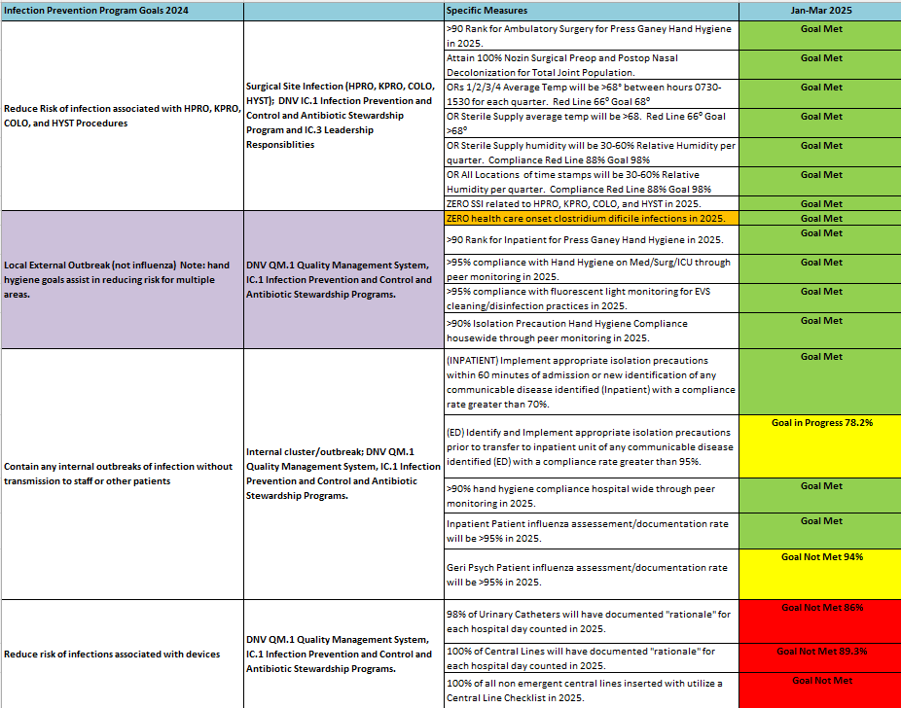

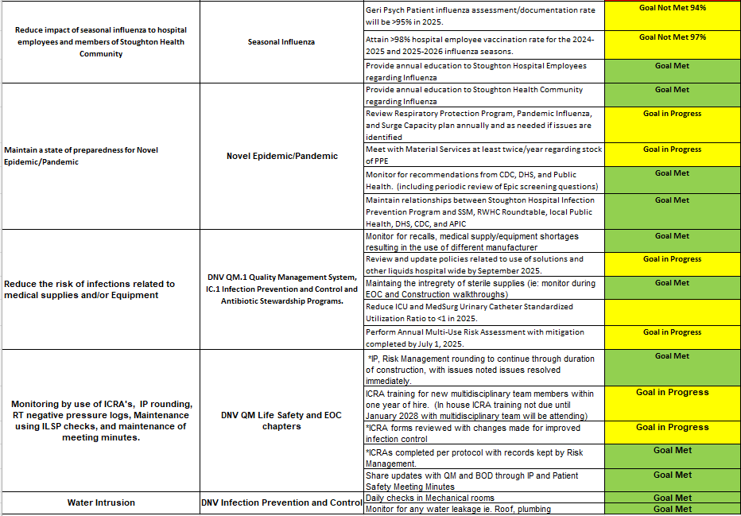
Updated 5/22/2025

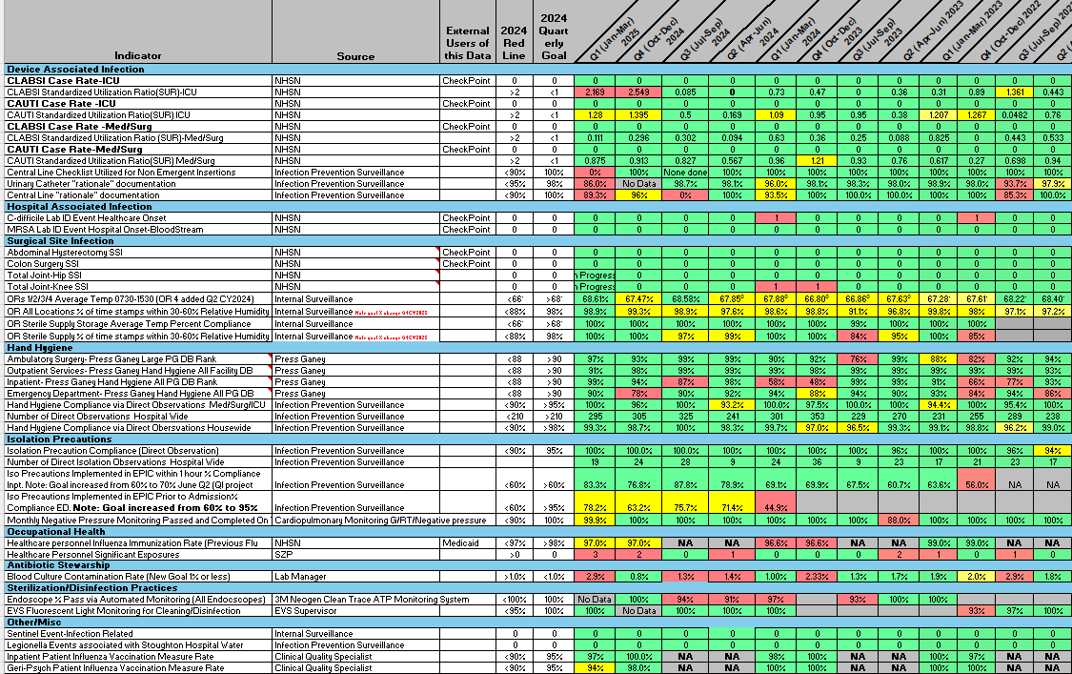
Updated 5/23/2025

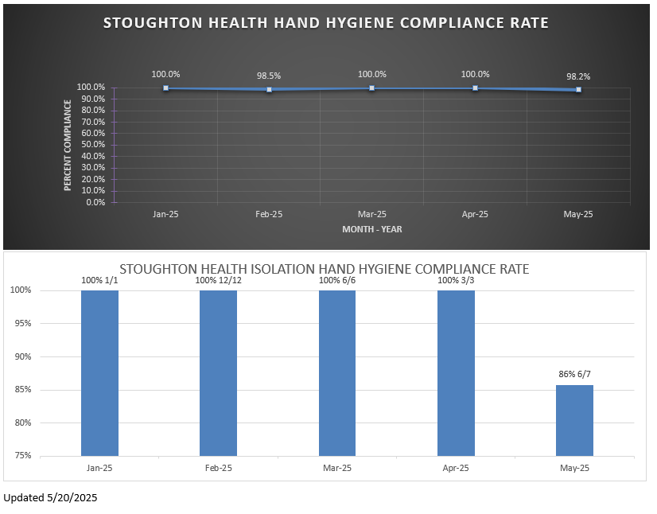

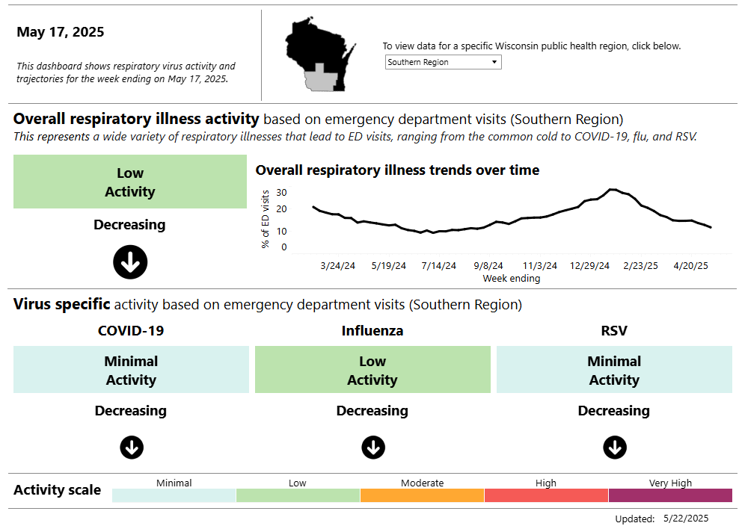

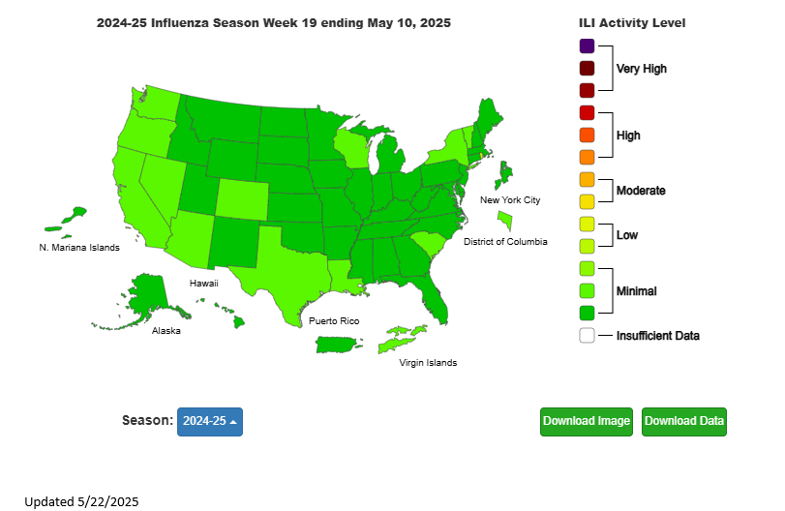

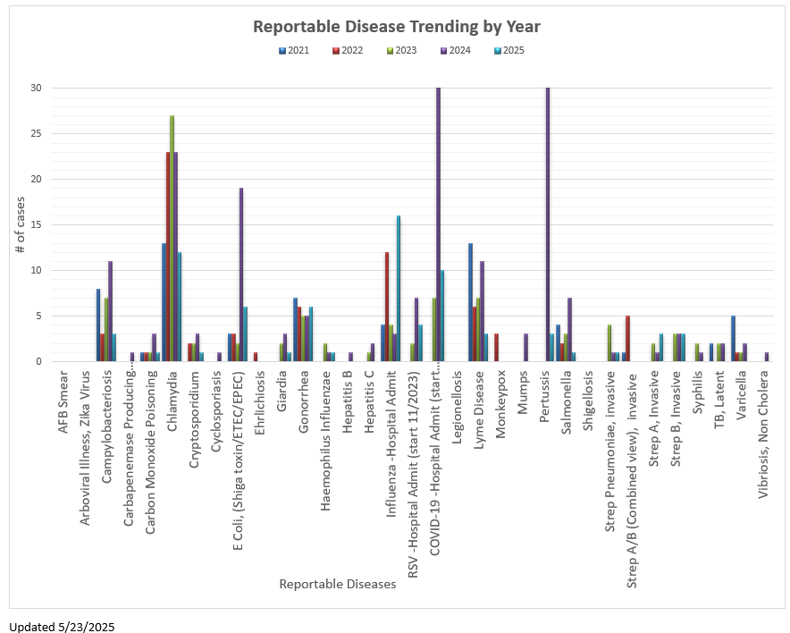

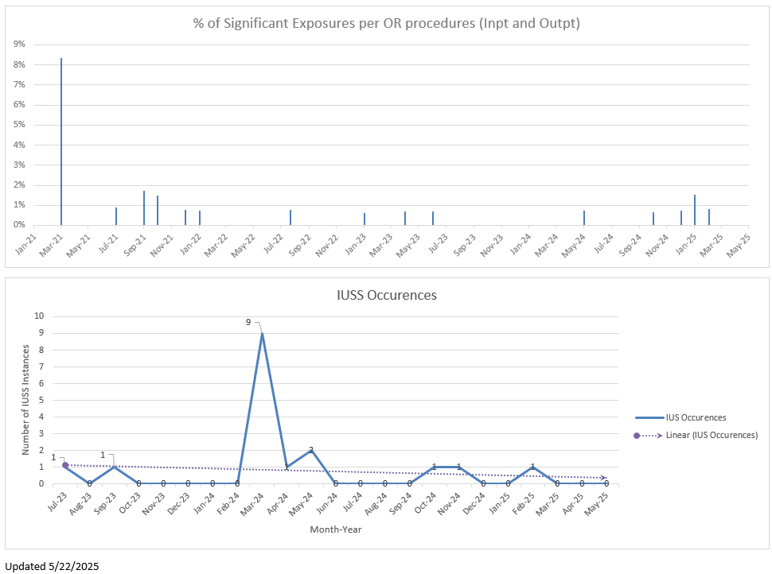

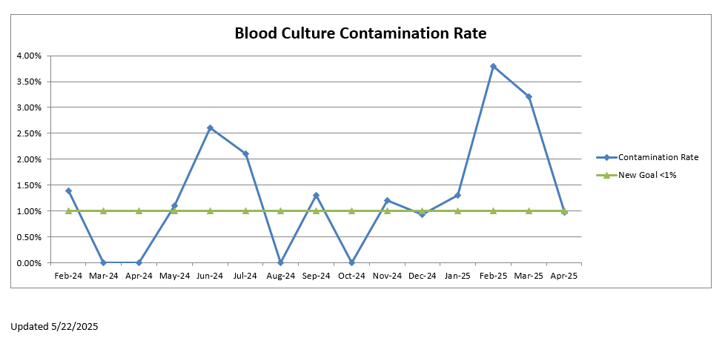

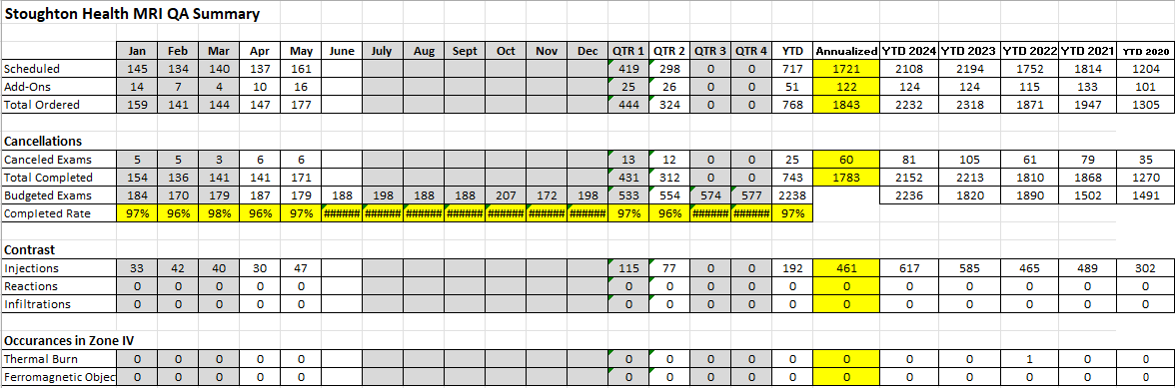

Surgical Services Report

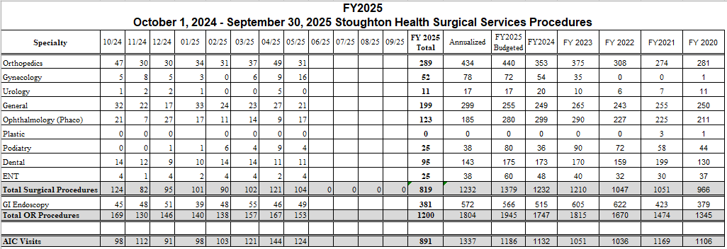

GP Percent Occupancy Report:

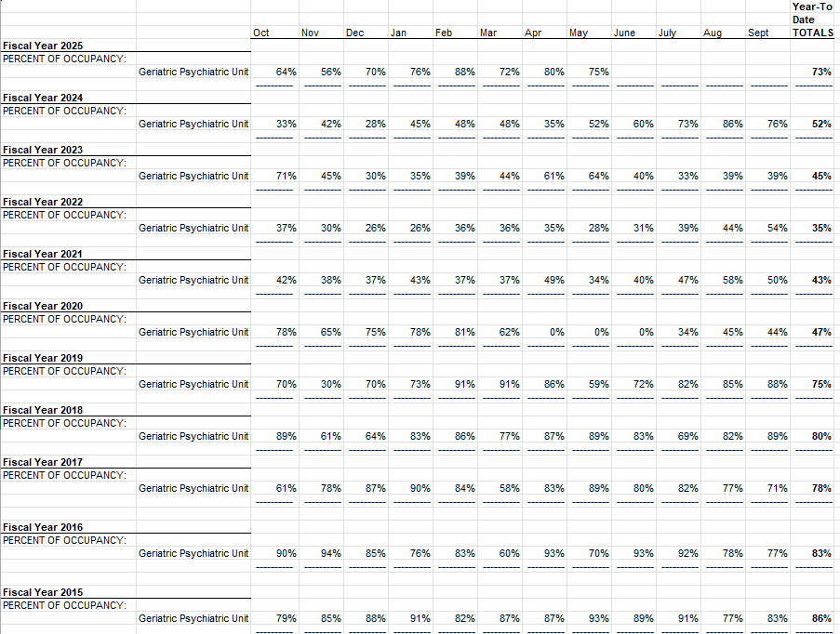

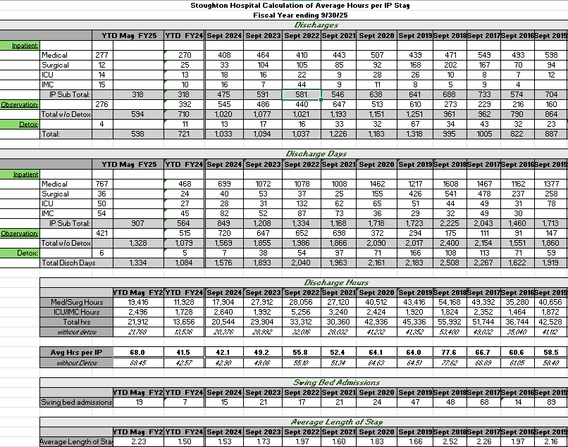
May 2025
Procurement QI Monitor
(applies to all deaths)
Inpatient/Obs -1
Emergency Room -0
Hospice Acute 0
Geri-Psych -0

1) Was Statline contacted? Yes: 1 N/A: 0 No/Unable to Determine: 0

2) The following exclusion from donation existed:
(1) Not a suitable donor determined by procurement organization
(0) Follow-up screening/consent to be done with Coroner (coroner’s case)
(0) deceased made prior refusal known, such as POA-HC or wallet card – copy placed in medical record
(0) eligibility section not completed
(0) eligibility completed by nurse but Statline not called

3) Is there documentation of first person consent from the Donor Registry per Stat line?
Yes: 0 No: 1

4) Is there evidence the family of potential donor were informed of the option to
donate organs, tissues and eyes?
Yes: 0 No: 0 N/A: 1

5) Is there documentation that the patient’s families interested in donation were offered the informational brochure? (not required)
Yes: 0 No: 0 N/A: 1

6) Was eligible donor, HC-POA or next of kin response documented in patient’s record?
Agreed to consent: 0 Refused consent: 0 Documentation lacking: 0 N/A: 1

7) The Stoughton Hospital staff avoided any inappropriate approach and assisted Donor services staff with a phone approach.
Yes: 0 No: 0 N/A: 1

8) Organs, tissues, or eyes donated: None

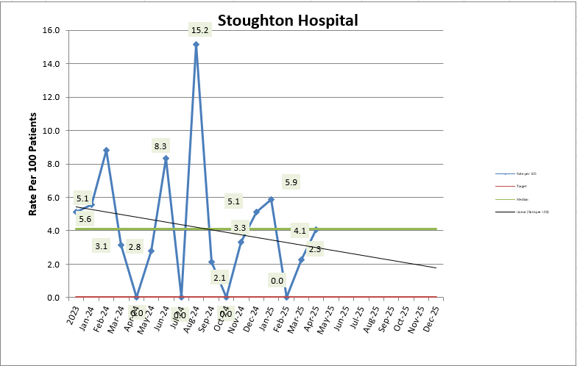

The rate of 4.1 readmissions/100 eligible discharges is based on our actual data of 2 readmissions for 49 eligible discharges for April. Both patients were originally admitted with infections (one with UTI/probable norovirus and one with sepsis and pneumonia). Both index stays were short (1 day and 2 days respectively). Both patients returned within a short period of time (2 days and 4 days respectively). Both were discharged to home on the index stay (1 to her personal home, 1 to assisted living). One returned with altered mental status/acute psychosis. The other patient returned with respiratory failure after developing COVID at the assisted living facility where there was an outbreak. Both readmission stays were 3 days in length. Following the readmission, both were discharged to a different level of care (1 to Meriter and 1 to Swing Bed Status). Both were Medicare patients.

